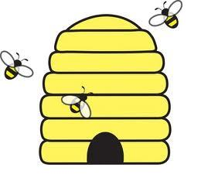Beehives
Match hive number to bees; Friend of 10 hive and bees; Add bees to get the daily number.
Elephants
Match the hive and collect the corresponding number of bees. An adult checks to be sure it is correct by counting the bees.
Penguins
Friends of 10. Pick a hive and state the number as the starting number and then calculating how many more to make 10. An adult checks to be sure it is correct by counting the bees.
Fish
The number today is………….. to 20
Students get a beehive and workout how many more they need to reach the daily number, by adding bees. Write the sum on paper. Repeat the activity with another number. An adult checks the sum.
Crocodiles
The number today is………….. to 50
Students get 2 beehives and workout how many more they need to reach the daily number. Write the sum on paper. Repeat the activity with another number. (NO bees) An adult checks the sum.
Foxes

Not suitable for play at this level.

