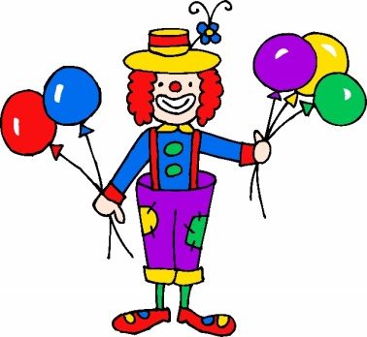Colourful Clowns
Roll the dice to cover the clown’s spots.
Elephants
1 Clown Baseboard for each student. Take turns to roll a dice and cover the spot’s on the clown’s trousers. On the next roll repeat using a different colour. Continue until all circles are covered. To finish the student must roll the exact number to cover all circles.
Penguins
1 Clown Baseboard for each student. Take turns to roll a dice and cover the spot’s on the clown’s trousers. On a piece of paper write the Friend of 10 sum. To finish the student must roll the exact number to cover all 10 circles.
Fish
1 Clown with Juggling Balls Baseboard for each student. Starting at 7 (in your head) Roll dice and subtract the number and cover that number of spot’s on the clown’s trousers. On a piece of paper write the subtraction sum. Continue until all the circles are covered. To finish the student must throw the exact number to cover all circles.
Crocodiles
1 Clown with Juggling Balls Baseboard for each student. Take turns to roll a dice, double the number and cover the spot’s on the clown’s trousers and/or juggling balls. On a piece of paper write the subtraction sum. Continue until all circles are covered. To finish the student must roll the exact number to cover all circles.
Foxes

Not suitable for play at this level.

