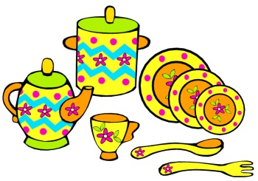Friends of 10 Tea Party
Find your friend. First match, then higher or lower, then a friend of 10, then friend to 20 and 3 addends to 20.
Elephants
Students are each given a number (1-10). On a signal they have to find the same number as them. Variation - Make that number with concrete materials.
Penguins
Students are each given a number (1-20). On a signal they have to find a number that is bigger or smaller than their number.

Fish
Students are each given a number (1-10). On a signal they have to find their friend of 10.
Crocodiles
Students are each given a number (1-20). On a signal they have to find their friend of ...12, 14 (Adult picks a number).
Variation: A number larger than... (Adult picks a number)
Foxes
Students are each given a number (1-20). On a signal they have to find 3 cards to find that total.

