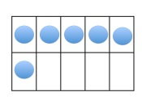 I have! Who has?
Equipment List

Included:
- I have! Who has? cards to 5
- I have! Who has? cards to 10
- I have! Who has? cards to 20
- I have! Who has? cards 2 Addends
- I have! Who has? cards 3 Addends

From your Maths Kit:

Other:

