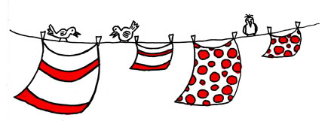 Peg the Clothes on the Line

Peg the clothes on the line in order from 10 to 20. Then find Friends of 10 and then combinations as asked by the adult.
Elephants
Use copies of shirt template with numbers 1-10. Students peg them on the line in order. Use different numbers as starting points to cement before and after. Variation Make multiple copies of shirts to play memory.
Penguins
Use copies of shirt template with numbers 1-20. Students peg them on the line in order. Use different numbers as starting points to cement before and after. Variation Make multiple copies of shirts to play memory.
Fish
Use copies of shirt template with numbers 1-20. Students peg them on the line in order. Take a numeral card 1-10 (then 1-20) to find the matching Friend of Ten (then Friends of numbers up to 20) t-shirt.
Crocodiles
Use copies of shirt template with numbers 1-20. Students peg them on the line in order. Say “What shirt wears double 3, 8, 6.....?”; “What shirt wears 11 plus 6 plus 1?”; What shirt wears 19 minus 5 minus 2?”
Foxes

Not suitable for play at this level.

