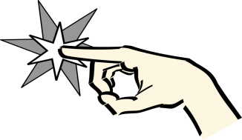 Zap
Students stand in a circle and count backwards as directed by the supervisor. If they give an incorrect response or have the end point they say ”Zap” and sit down. Continue until only one person is standing.
Elephants
Students stand in a circle. Students count backwards from 10 to 0 in sequence. If they make a mistake they say “Zap” and sit down. When sequence reaches 0 the student calls out ZAP instead and sits down. Continue counting until only one student is standing.
Penguins
Students stand in a circle. Students count backwards from 20 to 0 in sequence. If they make a mistake they say “Zap” and sit down. When sequence reaches 0 the student calls out ZAP instead and sits down. Continue counting until only one student is standing. (Extend to backward counting by2’s)
Fish
Students stand in a circle. Students count backwards from 30 to 0 in sequence. If they make a mistake they say “Zap” and sit down. When sequence reaches 0 the student calls out ZAP instead and sits down. Continue counting until only one student is standing. (Extend to backward counting by2’s and 5’s up to 50)
Crocodiles
Students stand in a circle. Students count backwards from 100 within a given range e.g. 88-60 in sequence. If they make a mistake they say “Zap” and sit down. When the sequence reaches the end point the student calls out ZAP instead. Continue counting until only one student is standing. (Extend to backward counting by2’s, 3’s, 4’s, 5’s and 10’s)
Foxes
Students stand in a circle. Students count backwards from 1000 within a given range e.g. 880-690 in sequence. If they make a mistake they say “Zap” and sit down. When the sequence reaches the end point the student calls out ZAP instead. Continue counting until only one student is standing. (Extend to backward counting by2’s, 3’s, 4’s, 5’s and 10’s)

