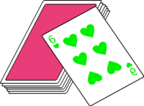
Flippin’ Cards
Students flip cards; visualise and add cards; find “Friends of 10”; and say the sum of cards. The player with the most cards is the winner.
Elephants
Students take turns flipping over cards and calling out the number on cards.
Penguins
One student turns over a card and then flips it back over. The other student flips a card and then must visualise the concealed card to add it to their facing up card.
Fish
Students place cards into 2 piles. Students flip 2 cards at the same time and place them side by side. When they see a friend of 10 they snap and get to take the cards. Student with the most cards at end is the winner.
Crocodiles
Students place cards into 2 piles. (Then move to 3 piles.) Students flip 2 (Then 3) cards at the same time and place them side by side. Students add the cards. Student who says the total the quickest gets the cards. Student with most cards at end is the winner.
Foxes
Students place cards into a pile. Students flip 4 cards at the same time and place them side by side. Students add the cards. Student who says total the quickest gets the cards. Student with the most cards at end is the winner.

